EcoFoam Solutions

Business Plan.

A full circular supply chain for mattresses and other products using polyurethane foam.

Table of Contents

1. Table of Contents 2
2. Executive Summary. 5

Highlights. 5

6 year financial overview 5

1. EcoFoam Solutions 7

Objective of the Business Plan 7

Mission Statement. 7

Ownership 7

Sustainability 7

Key Strengths 8

Innovative Circular Business Model: 8

Strategic Partnerships: 8

Experienced Management Team: 8

Environmental and Sustainability Focus: 8

Access to Cutting-edge Technology: 8

Growing Market Demand: 8

Adaptability and Scalability: 9

Risk management 9

1. Supply Chain Risks 9

2. Technological Risks 9

3. Market Demand Risks 10

4. Regulatory and Environmental Risks 10

5. Financial Risks 10

6. Competition Risks 11

7. Operational Risks 11

8. Environmental and Social Impact Risks 11

1. Business Description. 13

Business Model 13

Input 13

Output 15

Keys to Success. 15

Management & Organization Structure. 16

Investments. 18

1. Supply Chain & Operations 19

Source 21

Collect 21

Dismantle & sort 21

Recycle & Upcycle 21

Sell & Deliver 22

Operations Center(s) 23

Location. 23

1. Market Overview and Sales Plan 24

Customers 24

Market growth 25

Competition 25

Pricing 25

Strategic growth directions 25

1. Scenario’s 27

Background 27

Scenario description 27

Scenario 1 27

Scenario 2 27

Scenario 3 27

Scenario 4 27

Scenario 5 27

Scenario choice 28

1. APPENDICES 28

Appendix 1 Amount of discarded mattresses in Thailand 29

Appendix 2 DC Locations of major retail chains 32

Appendix 3 Scenario calculations 34

Appendix 4 Start-Up Capital Needed 36

Introduction 36

Type of Cost 36

Variable 36

Fixed 36

Total Start-up Cost 36

Appendix 5 P&L Overview for the first 5 years 37

Appendix 6 Cash Flow Forecast 38

Appendix 7 Balance Sheet 39

# Executive Summary.

## Highlights.

*The development of the foam plant and commissioning will take approximately 12 months based on expected lead-time of machinery and building of the plant.*

*Due to an already available customer base, product portfolio and experience team, the start-up year will generate operational profit immediately. The start-up cost has been capitalized and incorporated in the total investment.*

*In the following years the revenue will grow based on expected autonomous market growth and gain of market share up to 10-11% in the 5th year after start-up with an average operational profit of 30% of the revenue.*

## 6 year financial overview

Below figure shows the financials for EcoFoam Solutions (EFS) over a 6 year period, whereby year 1 is the startup year.



Figure 1 Financial Highlights (details in Appendix 5 )

FX Rates: 38 THB for 1 EURO and 35 THB for 1 USD.

# EcoFoam Solutions

## Objective of the Business Plan

To get the company EcoFoam Solutions (EFS) started, up-and-running within 6 months, and continue to grow y-o-y as per the forecast.

## Mission Statement.

To create a Circular Supply Chain for Mattresses plus other products which contain Polyurethane (PU) foam.

## Ownership

EFS will have several shareholders who will be investing by using their knowledge, experience and network (sweat equity). Besides the shareholders there are also partner companies who will be participating in the same way, but without being shareholders. Both shareholders and partner companies will receive a remuneration for their time to put in the company.

## Sustainability

The base of EFS is to create a circular supply chain for EoL mattresses and other EoL products containing polyurethane foam. By fully recycling the products and bringing them back to their original raw materials, the lifespan of these raw materials will be extended. Obviously with the recycling process there is a yield factor to be taken into account.

The environmental impact of recycling a mattress for example will have the following benefits:

1. Reduce CO2: Recycling one mattress, reduces **25 kg of CO2**
2. Save electricity: Recycling one mattress saves **125 kWh**
3. Save blue water: Recycling one mattress saves **2.1 Liter**

These numbers are based on a wide global experience in geographies with established mattress recycling programs already implemented for several years, as well as scientific research by renowned universities.

## Key Strengths

EcoFoam Solutions possesses several unique strengths that position the company for success in the emerging circular economy and polyurethane foam recycling industry:

### Innovative Circular Business Model:

Our focus on creating a fully circular supply chain for mattresses and other PU foam products distinguishes us from traditional recycling companies. This innovative approach not only reduces waste but also creates sustainable value through upcycling and repurposing end-of-life products.

### Strategic Partnerships:

EcoFoam Solutions has built strong relationships with key players across the value chain, including mattress manufacturers, retailers, foam producers, and recycling technology providers. These partnerships ensure a reliable supply of raw materials and access to state-of-the-art recycling technologies.

### Experienced Management Team:

Our team includes industry veterans with deep knowledge in polyurethane foam production, recycling processes, and business operations in Southeast Asia. This expertise, combined with strategic leadership, gives us a competitive edge in both operational efficiency and market penetration.

### Environmental and Sustainability Focus:

With growing global demand for ecofriendly solutions, EcoFoam Solutions’ commitment to sustainability aligns perfectly with market trends. By actively reducing CO2 emissions and conserving natural resources, our company is poised to attract both environmentally conscious consumers and partners.

### Access to Cutting-edge Technology:

We leverage advanced recycling and upcycling technologies, such as repolyol production and foam shredding, which allow us to transform waste into valuable products efficiently. This technological advantage enables us to minimize costs while maximizing output quality.

### Growing Market Demand:

The increasing demand for sustainable materials in the mattress, furniture, automotive, and construction industries plays to our strengths. As one of the first movers in Thailand offering a full circular supply chain solution, we are well positioned to capture market share in a rapidly expanding segment.

### Adaptability and Scalability:

Our flexible operational model, including variable cost structures and partnerships with existing recycling companies, allows us to scale rapidly and adapt to changing market conditions. This adaptability will ensure long-term growth and profitability.

## Risk management

EcoFoam Solutions recognizes that a proactive approach to identifying and mitigating risks is essential to the long-term success and sustainability of the business. The company has implemented a comprehensive risk management strategy to address potential challenges that may arise in the course of operations. Below are the key risks and the corresponding mitigation strategies:

### Supply Chain Risks

**Risk**: Inconsistent or insufficient supply of end of life (EoL) mattresses and other polyurethane foam products could disrupt the recycling process.

**Mitigation**: We have established strong partnerships with multiple sources of raw materials, including public waste collection points, retail chains, and mattress manufacturers. By diversifying these sources, we reduce dependency on any single supplier. In addition, our proactive outreach and agreements with major retailers will ensure a steady stream of materials through initiatives like mattress return programs.

### Technological Risks

**Risk:** The performance and reliability of recycling technologies, such as repolyol reactors and shredding equipment, could impact operational efficiency.

**Mitigation:** EcoFoam Solutions will collaborate with experienced technology providers and conduct thorough testing before integrating new equipment into operations. We have also budgeted for regular maintenance and technological upgrades to minimize downtime and maximize efficiency. Additionally, we will invest in R&D to continuously improve our processes and adapt to any technological advances.

### Market Demand Risks

**Risk:** Fluctuating demand for recycled polyurethane materials, such as repolyol or rebonded foam, may impact revenue projections.

**Mitigation**: To hedge against market fluctuations, we will diversify our product offerings across several industries, including bedding, furniture, automotive, and construction. We will also work closely with our customers to provide tailored solutions that meet specific needs, ensuring longterm partnerships. Continuous monitoring of market trends will allow us to adjust pricing strategies and product focus accordingly.

### Regulatory and Environmental Risks

**Risk:** Changes in environmental regulations or failure to meet sustainability standards could lead to fines, increased operational costs, or reputational damage.

**Mitigation:** EcoFoam Solutions is committed to operating within the highest environmental and regulatory standards. We will stay abreast of legislative changes in Thailand and Southeast Asia, and adapt our processes to meet or exceed compliance requirements. We also aim to capitalize on government incentives for recycling and green initiatives, further aligning our business with regulatory expectations.

### Financial Risks

**Risk:** Inadequate funding or cash flow issues could hinder the company's ability to expand and operate efficiently.

**Mitigation:** The company will maintain a disciplined approach to financial management, ensuring sufficient liquidity for both short-term and long-term needs. We will actively pursue multiple financing options, including equity investments, loans, and government grants. Additionally, financial projections are regularly reviewed and adjusted to anticipate potential funding gaps.

### Competition Risks

**Risk:** As the market for circular supply chains and recycled materials grows, new competitors may enter the market, potentially reducing EcoFoam Solutions' market share.

**Mitigation:** EcoFoam Solutions will focus on differentiating itself through superior technology, strategic partnerships, and a strong commitment to sustainability. By forming long-term relationships with key players in the supply chain and investing in innovation, we will maintain our competitive edge. Our first mover advantage in Thailand's circular mattress supply chain will help establish us as a leader in the field.

### Operational Risks

**Risk:** Disruptions in operations due to logistics, labor shortages, or equipment failures could affect the company's ability to meet production targets.

**Mitigation:** The company will establish multiple operational centers close to collection points to minimize transportation delays. We will also implement crosstraining programs for staff to ensure operational flexibility and minimize the impact of labor shortages. Additionally, strategic investments in mobile press containers, efficient dismantling equipment, and intelligent logistics systems will mitigate potential operational disruptions.

### Environmental and Social Impact Risks

**Risk:** Negative environmental or social impacts could damage the company’s reputation and affect customer or partner relationships.

**Mitigation:** EcoFoam Solutions is committed to transparency and sustainability in every part of its operations. We will implement environmentally responsible recycling processes and work with local communities to raise awareness of circular initiatives. Our operations will actively contribute to reducing CO2 emissions and conserving natural resources, ensuring alignment with global sustainability goals.

# Business Description.

## Business Model

The business model is based on creating a sustainable, circular mattress manufacturing process, whilst adding value to the output, using available technologies and companies in Thailand plus technologies which are not yet available here.

## Input

The main raw materials for this business are end-of-life (EoL) mattresses. Currently there are approximately 2,5 – 3 Mio mattresses which are annually being discarded in Thailand. Appendix 1 demonstrates the validation of this number plus provides data on other South-East Asian countries.

Other EoL consumer products containing polyurethane foam are added to the raw materials, for example furniture. Also foam waste material (trimfoam) from foam manufacturers or converters is added to the volume. Right now the majority of all these products (>90%) are ending up as landfill or are being incinerated.

EFS will only invest in case technology is not yet available in Thailand and cooperate with existing recycling companies in Thailand. By keeping the cost as variable as possible, there is shorter implementation lead time and thereby return on investment.

Figure 2 Circular Mattress Supply Chain schematic

At the start of the company, EFS focuses on the circular mattress supply chain. The mattresses are gathered from various sources:

* Consumers through public waste collection points
* Retail Chains
* Mattress Manufacturers
* Online Shop comfort returns
* Own collection points
* Foam Manufacturers
* Foam Converters

## Output

The EoL mattresses and other PU containing products will be transformed into finished goods which can serve as raw materials for new products.

As an example, textile will be shredded into fibers which can be used to produce non-woven, felt or yarn. These can then be used to create various products, such as mattresses but also other products.

ESF invests in R&D to further explore possibilities for using the finished products into new products or components.

## Keys to Success.

**The integration of different companies into an integrated collaborating supply chain is the main key to success of this business model** . Collaborating with various partners in the value chain will enable the circular process and thereby create a circular mattress supply chain in Thailand. In addition the partners will add to the innovation capabilities of EFS plus increase the sustainability of the supply chain.

Other key success factors:

* State-of-the-art recycling and upcycling technology
* Experienced recycling partners
* Efficient collection process
* Raw Material availability and awareness
* Sufficient Finished Goods demand
* Market knowledge for end use
* Added value to finished goods
* Consumer awareness of circular initiatives

## Management & Organization Structure.

The management and organization structure of EFS is as follows:

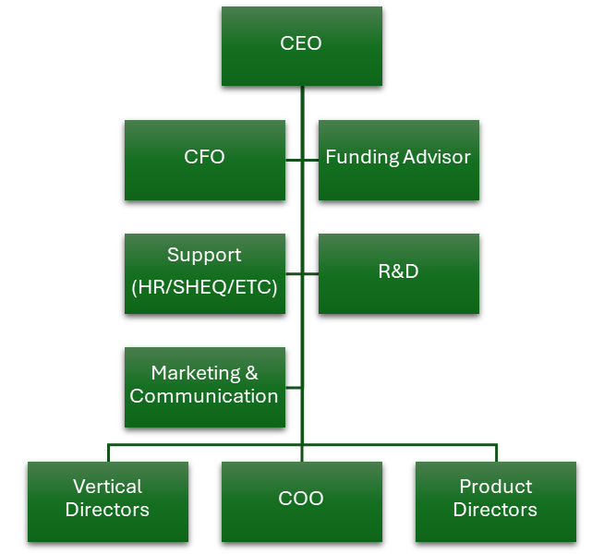

The vertical directors are responsible for a specific industry and focus on the supply side of the value chain. By creating agreements with various suppliers the raw material will be secured. The product directors have a responsibility for selling of the finished products and in some cases the recycling technology used. Below figure demonstrates the matrix structure in which these functions operate.

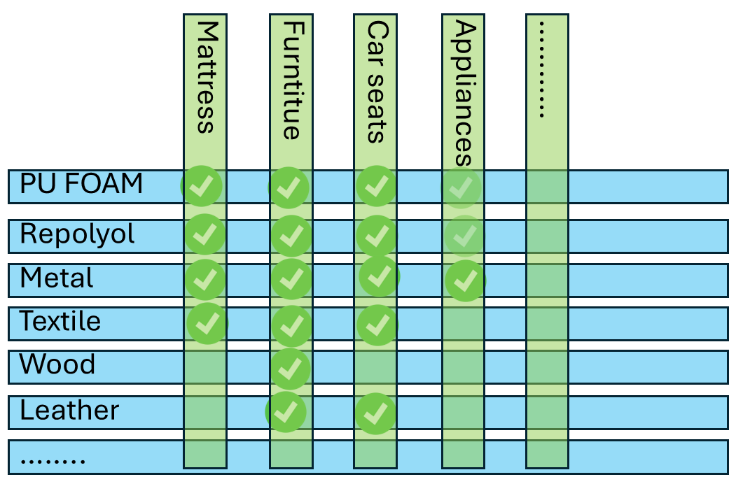

The reason for choosing this structure is the scalability of the organization plus the clear responsibility split between buying and selling.

## Investments.

In order to execute the operations and facilitate the collection process, investments need to be made. As we focus on keeping the cost structure variable, we have limited the investments to the absolute necessary:

1. **Intelligent mobile press containers:**

To be placed at the collection points and equipped with a communication device to self-report once the container is full and ready for collection.

1. **Shredders for foam and textile** (wood in future):

Given the ability within the shareholders of EFS, we do not need metal shredders.

1. **Bale press**

To create a more efficient process, the PU foam will be shredded and then compressed to bales.

1. **Repolyol reactor** plus auxiliary equipment

To produce the repolyol

1. Material Handling equipment

Forklifts, carts, conveyors and storage containers to move both raw materials and finished goods

1. **Various small equipment**

To split the mattress and other products, plus safety equipment (PPE) for the employees

# Supply Chain & Operations

The circular mattress supply chain looks as follows:

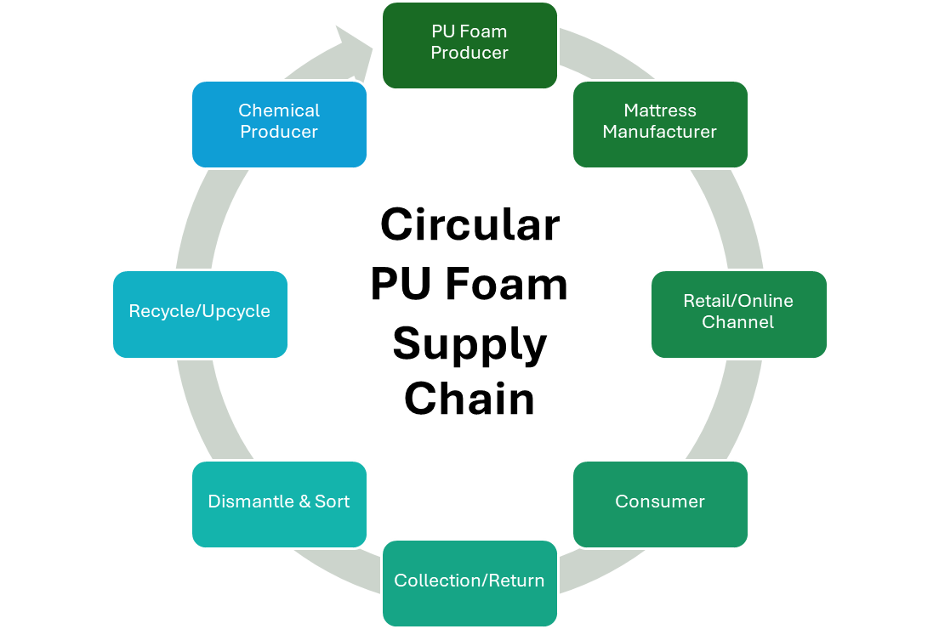

The main functions of EFS are:

1. Source raw materials (mattresses)
2. Collection of mattresses
3. Dismantle & Sort
4. Recycle / Upcycle (technology based)
5. Sell & Deliver

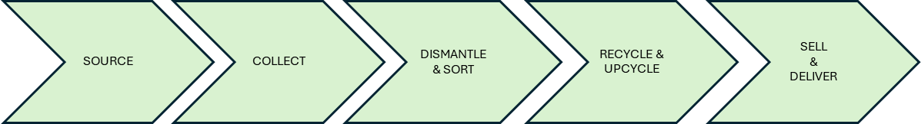

To establish this circular mattress supply chain, EFS will:

* Set up an efficient collection process
* Create OPS centers in the vicinity of the collection points
* Cooperate with existing recycling and upcycling companies
* Add value to the finished products by actively working with customers

## Source

The vertical directors are tasked with obtaining the raw materials against to best conditions. As mentioned one of the channels is to cooperate with retail chains such as e.g. Homepro. Homepro is offering a discount to their customers when they bring back their old mattress. All of these are then send to the Homepro DC where they are either sold for partial recycling (metal) or being incinerated.

By introducing carbon credits and making further agreements with retail chains, EFS will provide a service by collecting the mattresses from the DC’s by placing a press container and exchange it once it is full.

## Collect

Collection of mattresses is one of the most critical processes in the whole supply chain. By usage of mobile press containers, EFS will ensure that the collection will be done against the most efficient and sustainable ways. To ensure that the recycling is going well, it is very important that the mattresses must remain dry during collection.

## Dismantle & sort

The dismantling and sorting of the mattresses will be mainly a manual process supported by hand tools. Using conveyors and collection bins to ensure that materials are ready for further processing. During this process EFS will also ensure that contaminated raw materials are not processed. The staff will be trained on how to safely process the mattresses.

## Recycle & Upcycle

The recycling of mattresses requires the following technologies:

1. Shredding of steel as raw material for new metal
2. Shredding textile as raw material for non-woven, felt and yarn
3. Generating repolyol through a chemical process
4. Cutting and compressing for the raw material of rebonded foam
5. Shredding of foam as filling for pillows

Besides these process steps, ESF will also introduce rejuvenation of mattresses, whereby mattresses which are being returned from on-line shops not having passed the 100 day usage (so -called comfort returns), will be inspected, cleaned, repaired and getting a new zipped cover, so they can be re-sold.

## Sell & Deliver

Depending on the finished goods, the product directors will be in charge of ensuring sufficient customers are available to sell the products to. They will also be working with the customer on how the finished goods can be best handled in the manufacturing process of the customer (application engineering).

## Operations Center(s)

The Operation (OPS) Center(s) will be in charge of the operational planning and execution. Besides arranging pick-up and delivery transportation, the complete planning of the goods flow is taken care off in the OPS Center. The OPS center is the Control Tower of the total supply chain and to ensure a smooth flow.

The OPS Center(s) are performing the following operational functions:



## Location.

EcoFoam Solutions has two main locations; Headquarter and OPS center(s). Once activities increase, it is necessary to expand the number of OPS centers. At the start of the company we will limit it to **one**.

The HQ can basically be located in any geographic location. With the ability to work remotely and have meetings online there is no immediate need for a physical location.

The OPS centers require the following:

* Ability to process the mattresses/products without getting wet;
* Sufficient space to process the mattresses
* Easy accessible for normal trucks/container trucks
* Sufficient Loading docks / Level doors
* Close to the collection points
* In case of repolyol production we need to assess the specific requirements for this separately. Since it is not DG there should not be any major issue

Given the expectation that the major volume of the materials will be retrieved from the DC’s of the major retail chains, it is logic to choose a location within a reasonable radius of these DC’s. In Appendix 2 an overview of some of these DC’s is provided. A reasonable radius would be around 30 mins up to 60 mins maximum transportation time.

# Market Overview and Sales Plan

## Customers

For the different finished products there are several customer groups.

The main finished products are:

1. **PU foam**

The mattress foam is cut in smaller pieces and then compressed to be sold for rebonding purposes. Both domestic and international customers are targeted as demand is in both segments well available.

1. **Repolyol**

Being relatively a new product the market approach needs to be carefully developed. This material can be sold to both the chemical industry producing polyol (e.g. GC Polyols, IRPC, Dow, etc.) and to foam producers (BKK Foam, FoamTec, etc.). Support in the usage of this material is necessary for which we have the product director as well as the R&D department to support.

1. **Metal**

It is the most common material which is currently already being recycled. Since most of the metal is coming from the pocket springs being covered with a non-woven cover, special handling needs to be done to make the material more easily recyclable. Different ways can be used to add more value to the metal scraps.

1. **Textile**

After shredding the mattress covers and eliminating eventual zippers the textile is being shredded to fiber level. The fiber can be used for producing non-woven, felt or yarn.

## Market growth

Since we create a circular economy the need for our finished products can be measured by the demand for the originating products, i.e. mattresses and furniture. Or indirectly the demand for PU Foam, which given the growth percentages over the last 5 years plus additional market studies (Grandview and others) we predict the autonomous growth of the PU market in Thailand is estimated at 12-15% annually.

After the pandemic period the market has recovered to the same level as before. In addition the growth of foreign investment has been increasing, especially on the CN automotive side which has a multiplier effect due to the various Tier 1 and Tier 2 companies in need of PU foam (upholstery, headliner, dashboard, etc.)

## Competition

Being the first full circular mattress supply chain with the objective to collaborate with existing partners in the supply chain, EFS does not have a direct competition. Instead of creating yet another recycling company, EFS will combine existing strengths in the market by forming partnerships with existing companies.

## Pricing

Monitoring market pricing to ensure the best price/quality can be provided, is one of the key elements which the vertical directors are in charge of. Having long years of experience in their industry, they are fully aware of current market pricing and price developments.

## Strategic growth directions

EFS has different ways of growing the business in the future, below table provides an overview of these growth directions:

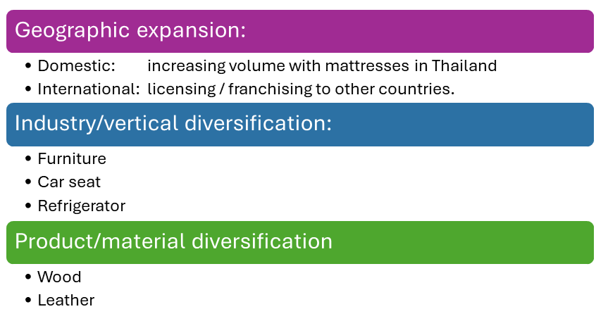

Table 1 Strategic Growth Directions

This is not a comprehensive overview, as there are many more verticals and products, which fall into the category of products containing polyurethane foam.

# Scenario’s

## Background

As there are multiple possibilities to start EFS, as set of 5 scenario’s has been created and evaluated. The most important **criteria** are **profitability (EBITDA), investment level and start-up time and cost**. Depending on the scenario there will be an impact on collection, staffing, utilities, financial cost, delivery cost and revenue. See Appendix 3 for more details on impact and results.

## Scenario description

### Scenario 1

This is the baseline scenario with the most conservative assumptions. In this scenario we start with mattresses, complete manual setup and although the investment for the repolyol reactor is taken into account, no benefits have been taken into the calculations.

### Scenario 2

In this scenario the investment is as in scenario 1, however benefits of the sales of repolyol have been taken into account.

### Scenario 3

Same as scenarion1 whereby furniture is added as raw material and thus adding wood to the finished goods. For this scenario an additional investment in a wood shredder has been taken in the calculations.

### Scenario 4

This is a similar as scenario 3, however the investment for the repolyol reactor is delayed until the moment that the cumulative capital reserve, combined with additional external investment funding, is sufficient to cover this investment. Therefore there is no difference in EBITDA, but there is in Net Profit since Financial Costs will be lower.

### Scenario 5

The last scenario is a combination of scenario 2 and 3. So both repolyol production, as well as adding a new raw material and finished good will be implemented.

## Scenario choice

The final choice for a scenario can be delayed until clarity has been obtained about the funding and financing of the company. Scenario 5 has a high investment level combined with a high revenue, this scenario also has the highest risk factor. The second best choice based on the criteria mentioned above is Scenario 4. For the purpose of this business plan **Scenario 4** has been chosen as the **preferred scenario**.

Appendix 3 provides more detail about the outcome of the scenario calculations.

# APPENDICES

## Appendix 1 Amount of discarded mattresses in Thailand

Based on lifespan and household numbers, the amount of mattresses now going for the majority into landfill or incineration for all of South East Asia is as follows:

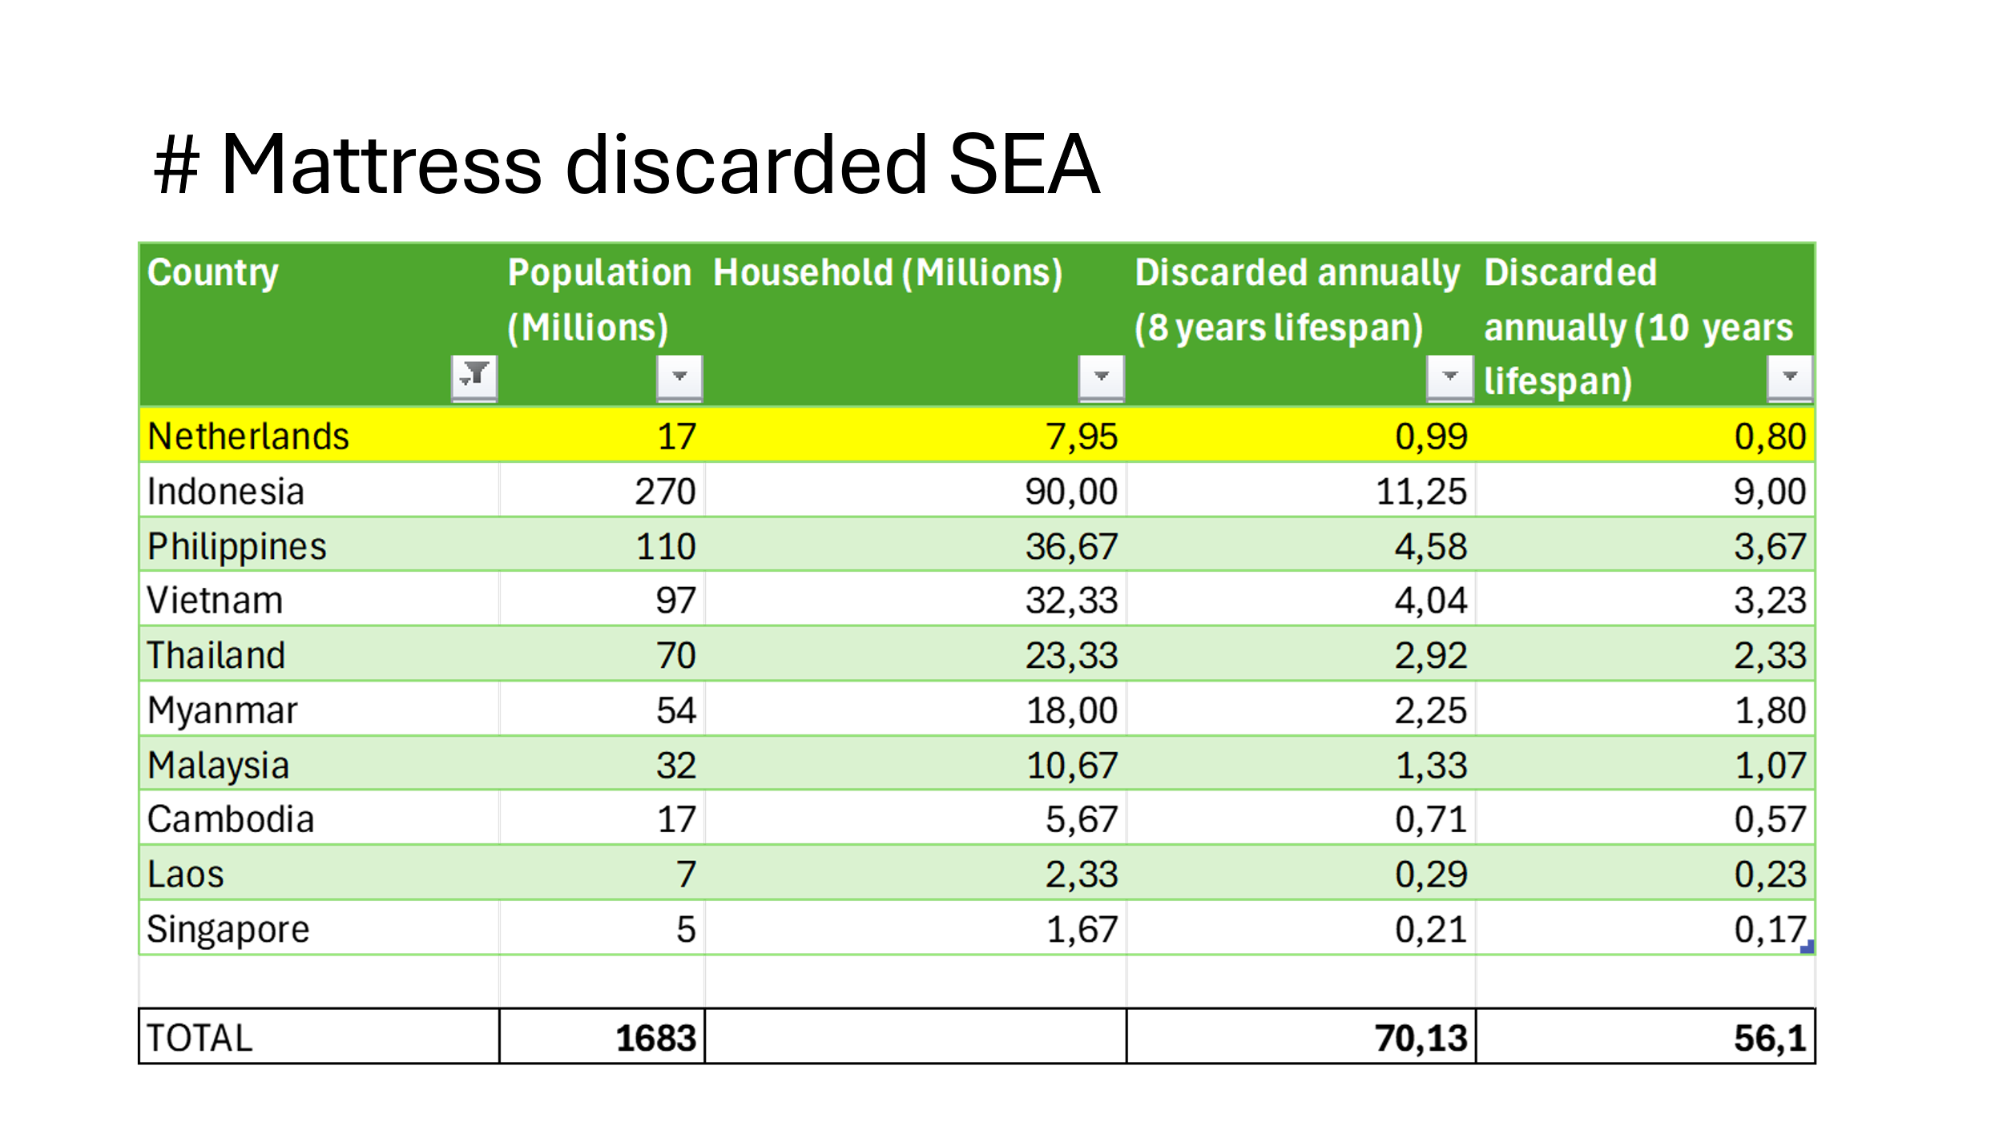

Based on this the amount for Thailand is **between 2.3 and 2.9 Mio per year.**

Even if the lifespan is around 10 years, the total amount is huge and more than enough to facilitate the business model. As a reference we have mentioned the Netherlands where at least 2 companies are operating on this business model for the last 10-15 years already.

To further validate the estimated number of mattresses discarded in Thailand some other points of view have been taken into account, such as the hospitality and institutional organizations (hospital, clinics, etc). In addition a comparison with the amount of mattresses sold to balance the forecast has been done.

**Hospitality Sector (Hotels, Resorts, Guesthouses)**

**Number of Accommodation Establishments:**

According to the Tourism Authority of Thailand, there are approximately 32,000 registered accommodation establishments in the country, ranging from hotels and resorts to guesthouses and hostels.

**Average Number of Rooms per Establishment:**

Assuming an average of 30 rooms per establishment and one mattress per room (some have more, others less), we get: 32,000 times 30 = 960,000 rooms/mattresses.

**Mattress Replacement Cycle:**

Hotels typically replace mattresses every 5–7 years due to wear and guest expectations.

Assuming a 6 year replacement cycle, the annual mattress replacement would be:

960,000 rooms / 6 = **160,000 mattresses per year.**

**2. Institutional Sector (Hospitals, Clinics, Other Facilities)**

**Number of Hospitals and Clinics:**

Thailand has approximately 1,400 hospitals (both public and private) and numerous clinics.

**Average Number of Beds per Hospital:**

Assuming an average of 150 beds per hospital: 1,400 hospitals times 150 beds = 210,000 beds.

**Mattress Replacement Cycle:**

Hospitals often replace mattresses every 3–5 years due to hygiene standards.

Assuming a 4 year replacement cycle, the annual mattress replacement would be:

210,000 beds /4 years = **52,500 mattresses per year**.

**3. Household Mattresses:**

Estimated at 2.3 to 2.8 million mattresses sold annually.

**Total Mattresses Sold Annually: Low estimate 2,526,800, High estimate 3,026,800**

## Appendix 2 DC Locations of major retail chains

With one the major collection points being the distribution centers of major retail chains, below demonstrates where these are located.

## Appendix 3 Scenario calculations

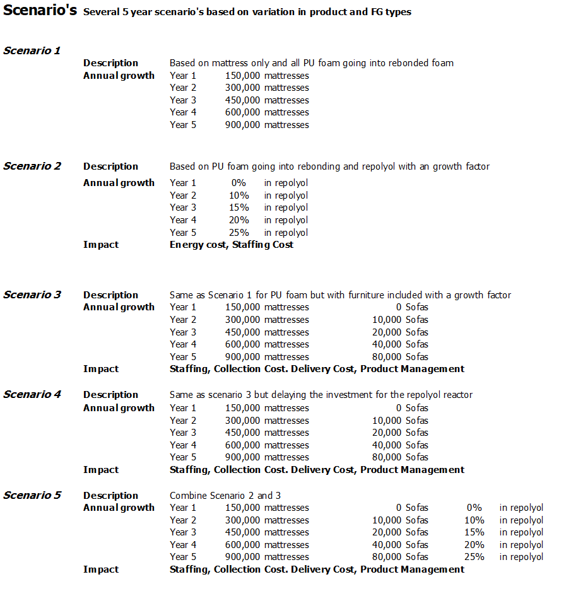

Differences in COGS (Cost of Goods Sold) are related to the differences between the various scenarios.

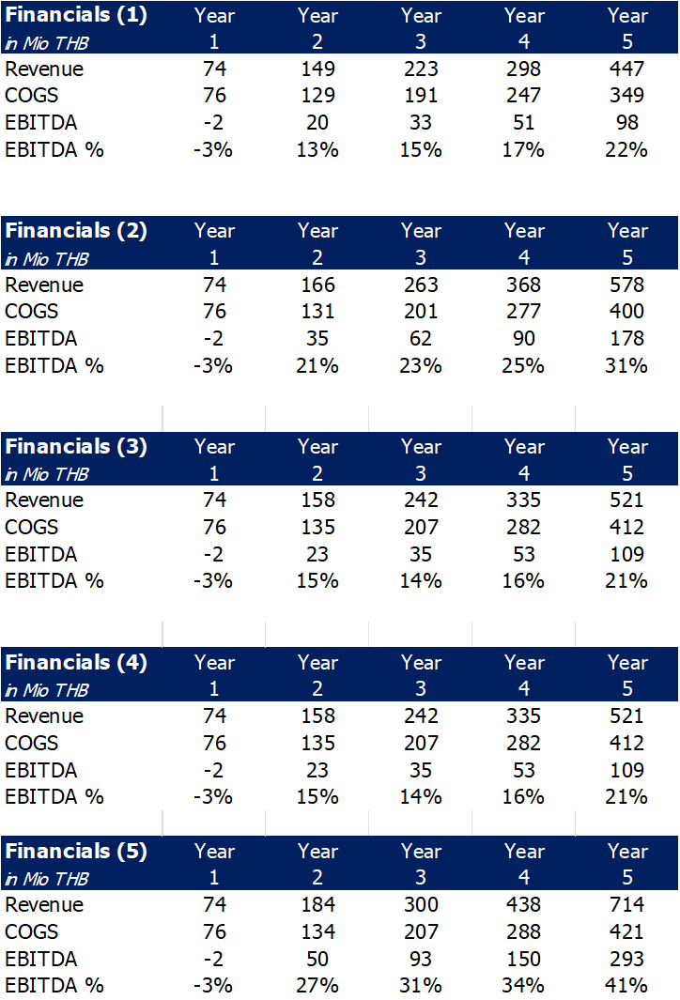

## Appendix 4 Start-Up Capital Needed

### Introduction

The start-up expenses have been calculated based on a volume ramp scenario in the first year. The growth curve for mattresses is in the figure below.

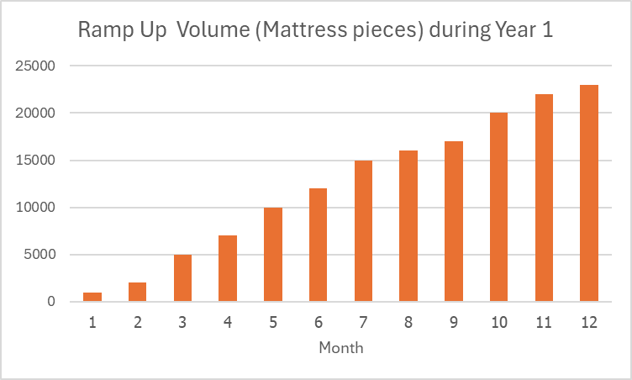

### Type of Cost

There are 2 types of cost, variable and fixed. The variable cost will change when the volume changes, whilst the fixed cost will stay constant.

### Variable

* Raw Materials
* Staffing
* Collection
* Maintenance
* Utilities

### Fixed

* Facility rent
* Overhead

### Total Start-up Cost

Based on the above mentioned ramp-up volumes the total cost for the first six months of year one are approximately 25 Mio THB. In the most negative scenario there will not be an income yet, and that would mean this amount needs to be taken as a short term loan to facilitate the start-up. See also Appendix 5.

## Appendix 5 P&L Overview for the first 5 years



## Appendix 6 Cash Flow Forecast

*To be added based upon the structure of funding*

## Appendix 7 Balance Sheet

*To be added based upon the structure of funding*